# CS 255 System Design Document Template

By: Bee Best

## UML Diagrams

### UML Use Case Diagram

### 

### UML Activity Diagrams

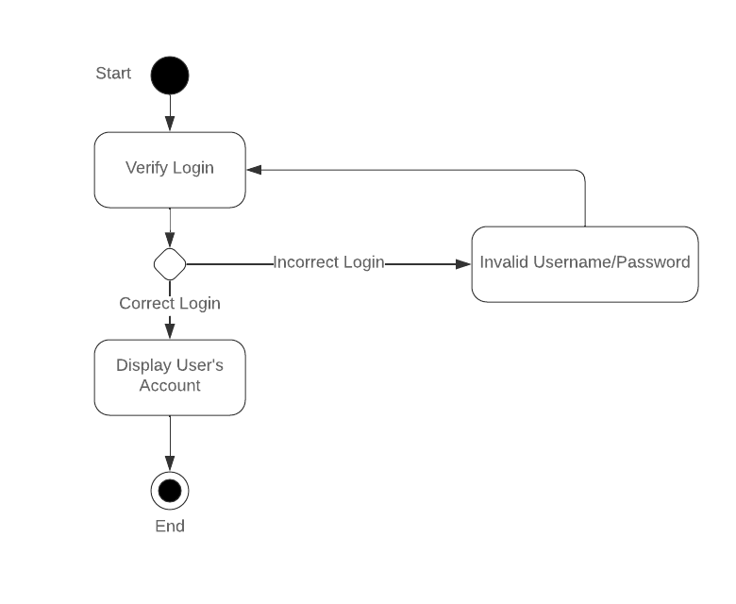

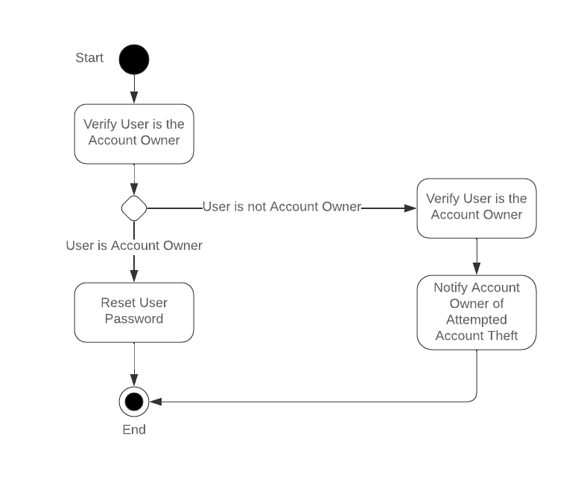

### UML Sequence Diagram

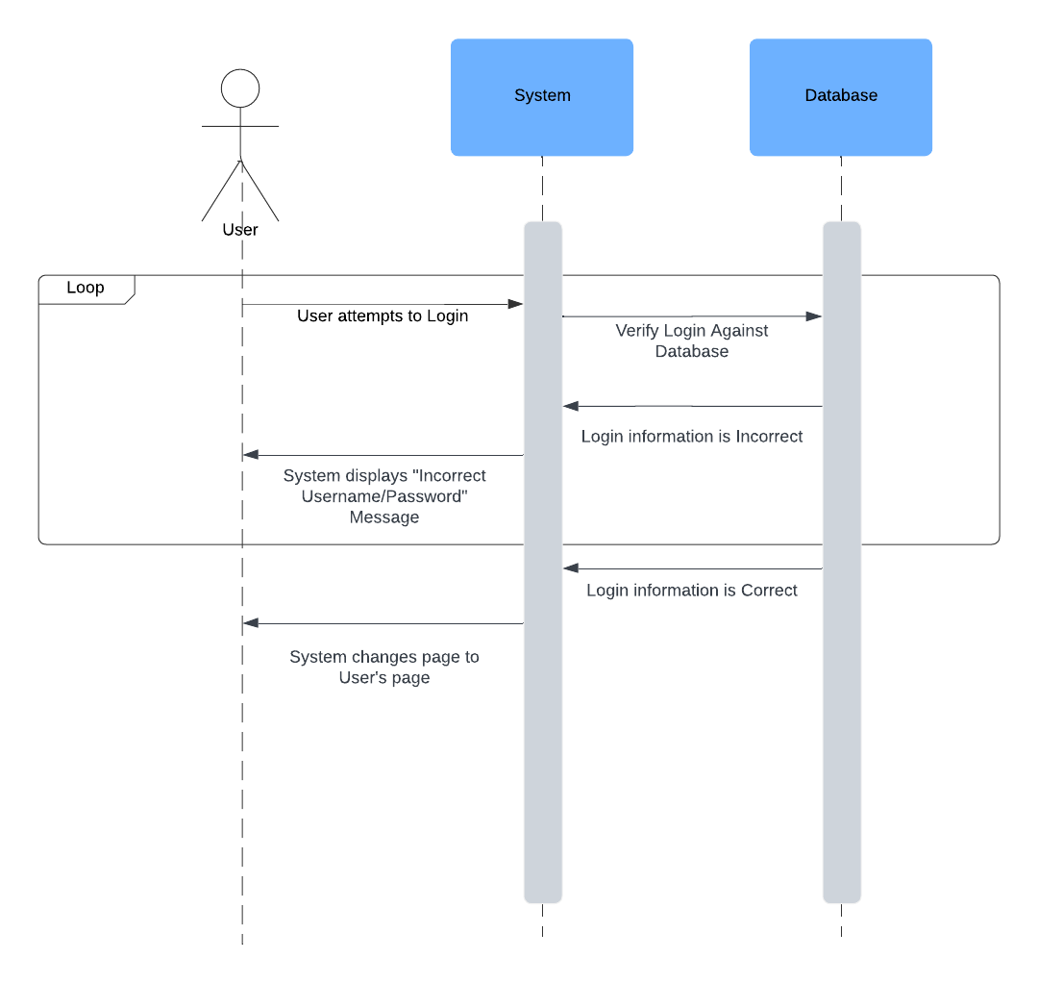

### UML Class Diagram

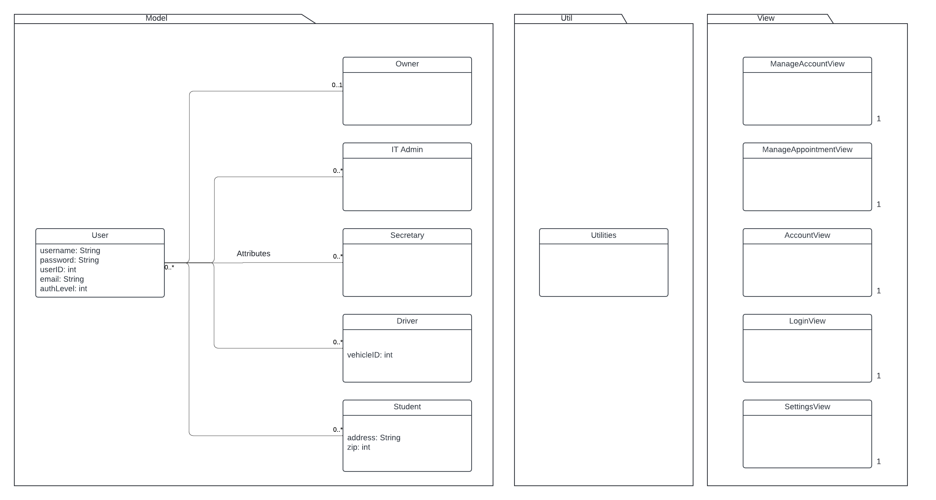

*I’m really annoyed… I didn’t realize the model package had a huge default text for “Attributes” still in it until way later… Just ignore that part please. And also the fact that the Secretary class is one pixel too high so there is a tiny turn in the line (I noticed it and now you have to as well).

## Technical Requirements

Computers for development/testing

Phones for testing mobile access to site

Differing levels of access based on who is logged in

Validate Login

Validate User Payments

Account Login

Account Password Reset

Management of Packages

Management of Accounts

Management of Appointments

Cloud Servers